#Max Sales for each item Map reduce program

Description: In this program we will find the maximum sales per each item.We will use the combiner concept in mapreduce.

Why is combiner needed in MapReduce:
When a MapReduce job is executed and the mappers start producing output a lot of processing happens with in the Hadoop framework knows as the shuffling and sorting phase.
Map output is partitioned based on the number of reducers, those partitions are also sorted and then written to local disk.
Then the data, from the nodes where maps are running, is transferred to the nodes where reducers are running. Since a single reducer will get its input from several mappers so all that data from several maps is transferred to the reducer and merged again to form the complete input for the reduce task.
As you can see all this processing requires memory, network bandwidth and I/O. That is where combiner in Hadoop can help by minimizing the data that is sent to the reducer.
Combiner function in MapReduce:

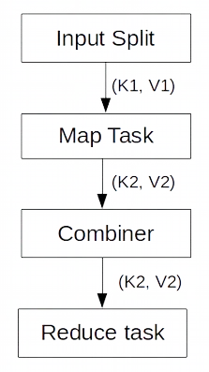

For example– Suppose you have sales data of several items and you are trying to find the maximum sales number per item. For Item1 if following (key,value) pair are the output of Map-1 and Map-2.
Map-1
(Item1, 300)
(Item1, 250)
(Item1, 340)
(Item1, 450)
Map-2
(Item1, 120)
(Item1, 540)
(Item1, 290)
(Item1, 300)
Then the reduce function which gets data for this key (Item1) will receive all these (key, value) pairs as input after the shuffle phase.

[Item1,(300,250,340,450,120,540,290,300)]

Resulting in final output - (Item1, 540)
If you are using a combiner in MapReduce job and the reducer class itself is used as the combiner class then combiner will be called for each map output.
Map-1 Combiner output
(Item1, 450)

Map-2 Combiner output
(Item1, 540)

Input to Reducer - [Item1, (450, 540)]
Resulting in final output - (Item1, 540)
So you can see by using a combiner map output is reduced which means less data is written to disk and less data is transferred to reducer nodes.

Though it is not always possible to use the reducer as the combiner class, classic example of this constraint is calculation of average.
For example- If there are two maps with (key, value) pair as following
Map-1 (1,4,7) and Map-2 (8,9)
Then reduce function will calculate average as – (1+4+7+8+9)/5 = 29/5 = 5.8
where as with combiner where average will also be calculated per map output
Map-1 – (1+4+7)/3 = 12/3 = 4
Map-2 – (8+9)/2 = 17/2 = 8.5
So the average calculated at reduce side will be – (4+8.5)/2 = 12.5/2 = 6.25

Combiner with MapReduce example

Step 1: Create a java project called MaxSales in eclipse.

File-> New-> Java Project-> Give the name of the project as “MaxSales”
Step2: import all the hadoop related jar file to eclipse.
Right Click on “MaxSales” project and click on properties

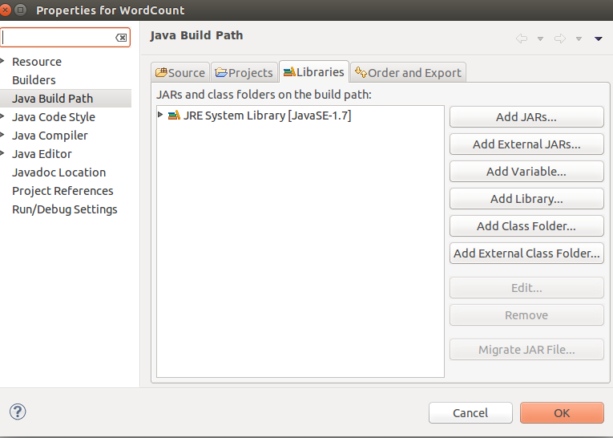
under libraries-> click on Add External JARs

import all below jar files from below paths,
from $HADOOP_HOME/share/hadoop/client path import all jars
select jar files and click ok.
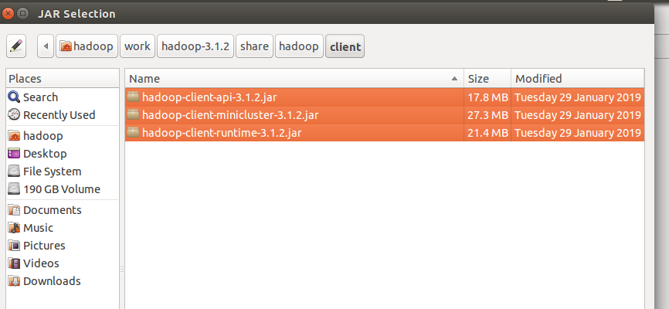
Again click on the Add External JARs and
import all below jar files from below paths,
from $HADOOP_HOME/share/hadoop/common path import all jars
select jar files and click ok.

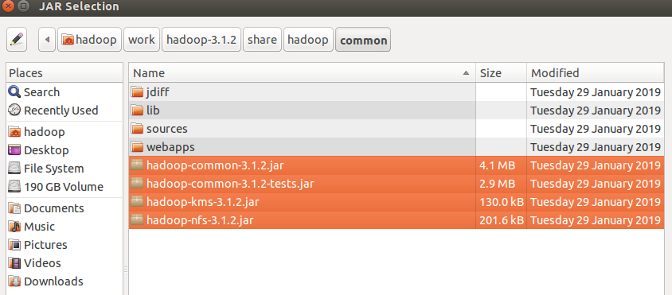
Again click on the Add External JARs and
import all below jar files from below paths,
from $HADOOP_HOME/share/hadoop/common/lib path import all jars
select jar files and click ok.

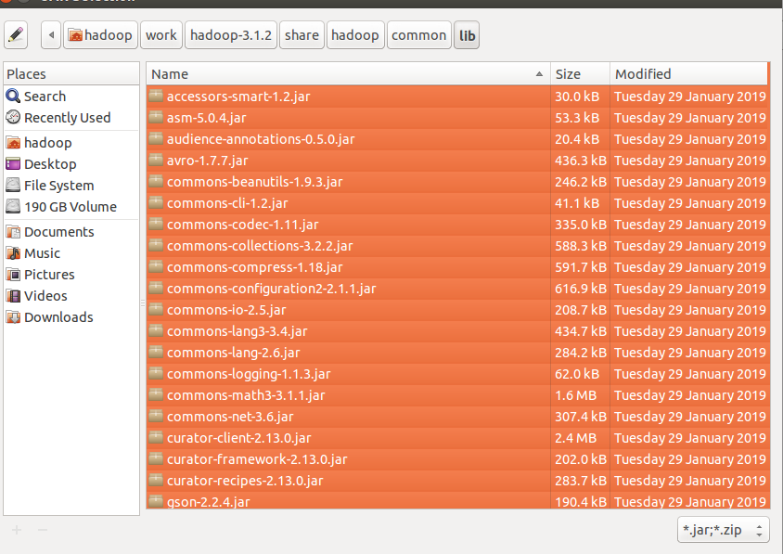
Again click on the Add External JARs and
import all below jar files from below paths,
from $HADOOP_HOME/share/hadoop/hdfs path import all jars
select jar files and click ok.

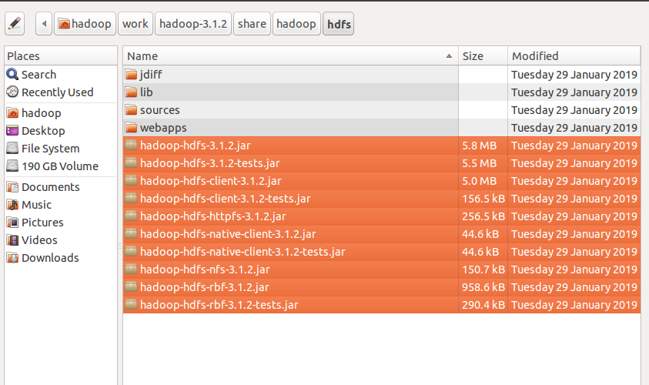

Again click on the Add External JARs and
import all below jar files from below paths,
from $HADOOP_HOME/share/hadoop/mapreduce path import all jars
select jar files and click ok.
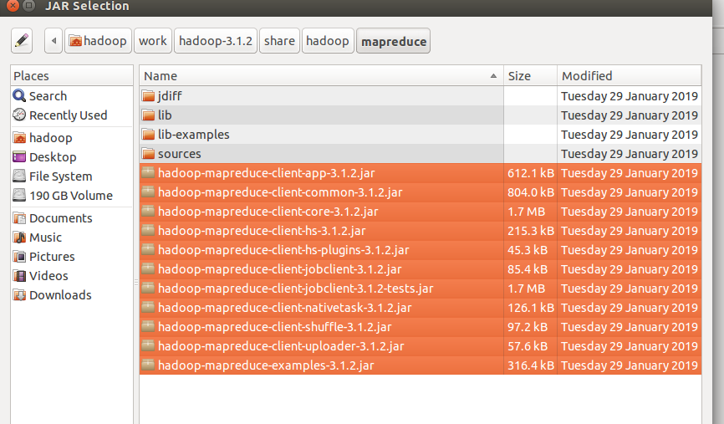
Again click on the Add External JARs and
import all below jar files from below paths,
from $HADOOP_HOME/share/hadoop/yarn path import all jars
select jar files and click ok.
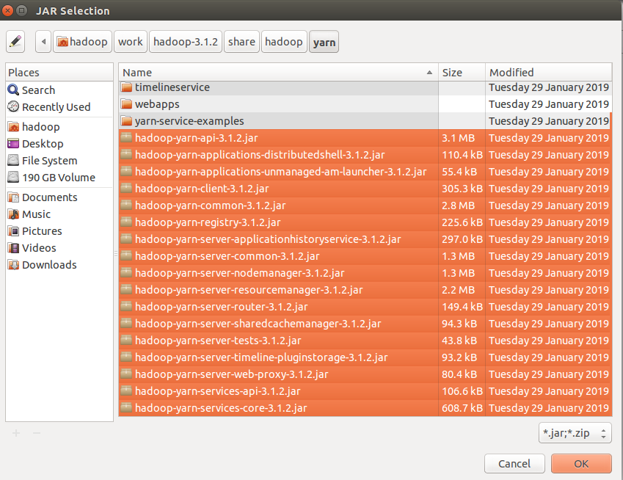

Step 3: Create a package in the package
right click on the src folder in “MaxSales” project-> New ->package
give any package name as “com.ramesh.MaxSales” -> Finish

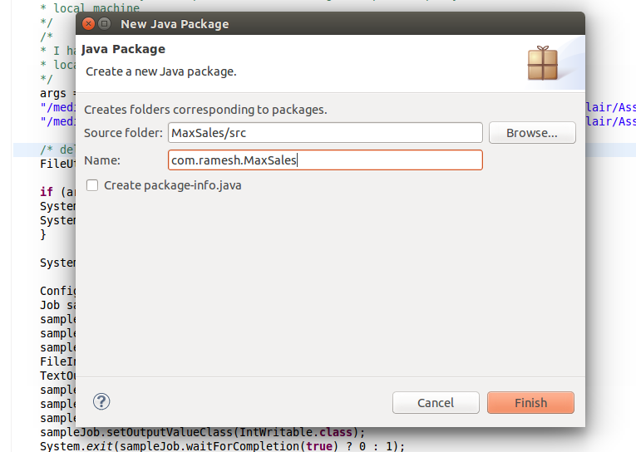

Step 4: create a class files
right click on the package name -> New ->class
give class name as “MaxSalesMapper” -> Finish

similarly create “MaxSalesReducer” and MaxSalesDriver class files.

Code for these class files is attached .

Mapper Class: MaxSalesMapper.java

Reducer Class: MaxSalesReducer.java

Driver Class: MaxSalesDriver.java

input file:

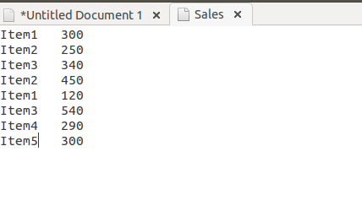

i am giving the path of the file in my local and output path in my local machine
Input path: "/media/hadoop/156d5b2f-6481-4a81-b1bb-56e2179981bb1/ramesh/2018 life/hadoop/DataFlair/Assignments/2.Combiner-Maximum Sales per Item/input_data/Sales"

Output path: "/media/hadoop/156d5b2f-6481-4a81-b1bb-56e2179981bb1/ramesh/2018 life/hadoop/DataFlair/Assignments//2.Combiner-Maximum Sales per Item//output_data/"

Run the Job:
right click-> Run As -> Java Application

Verify the result in the Output path:

